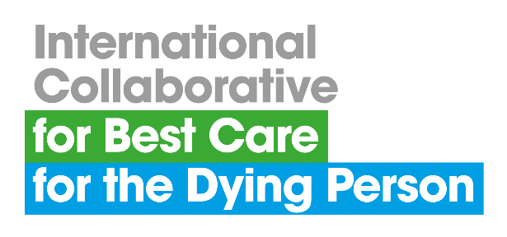
ABSTRACT SUBMISSION PROFORMA
Extended submission deadline Friday 27 February 2026
Please email your completed proforma to
admin@bestcareforthedying.org

8th Annual Summer School
Malaga, Spain, 11-12 May 2025
Abstracts are invited for presentation (oral or poster) on topics relating to research and innovation in palliative and end of life care.
ABSTRACT
Organisation name
Organisation address
Corresponding Author Name
Contact email
Contact telephone
Abstract Title
Author(s) and Affiliations
Background
Aim(s)
Method(s)
Results
Conclusion(s)
Please refer to the abstract submission guidance overleaf before completing the proforma.

GUIDANCE FOR ABSTRACT SUBMISSION
SUBMISSION
- The abstract submission proforma must be used for all submissions.
- Abstracts must be prepared in English and submitted via email to the following address: admin@bestcareforthedying.org
- Confirmation of receipt, including an abstract reference code, will be sent to the e-mail address provided with the submission.

CONTENT OF ABSTRACT SUBMISSION
The title should be brief, using a maximum of 15 words, and should clearly indicate the nature of the investigation.
- Full names should be used, and the first author should be the presenting author.
- Affiliations must include the name of the institutional affiliation, city and country.
- Abstracts should contain no more than 250 words (excluding author details).
- Please ensure whole words are used rather than abbreviations or special characters.

NOTIFICATION
- All submitted abstracts will be reviewed and selected by the members of the conference organising team.
- Author notification will be made in due course using the contact email address included on the submission proforma.

CONTACT
If you would like to discuss abstract submission with a member of the conference organising team, please contact the Coordinating Centre Administrator on +44 (0)151 794 8886 or email admin@bestcareforthedying.org.

Extended abstract submission deadline: 27 February 2026

